1. Software Installation
We shall use a portable version of Cygwin which is a UNIX-like environment and command-line interface. With this software, you should be able to develop and run your programs without login in to the sunfire machine.
Cygwin can be installed on a portable USB thumb-drive or external hard-disk so that you can plug-and-play on any machine to do your work. We suggest a minimum disk space of 512MB for the installation. Cygwin need not be the sole application on your storage device, so you can install together with your favourite media files on your media players, provided that these are visible as removable storage devices on the machines to which they are plugged in.
The detailed setup instructions for Windows and Mac machines are given below. Linux/FreeBSD users should be competent enough to perform the proper set up; just take the Mac instructions as a guide.
Download cygwin.zip (click on this link) and extract the contents onto your portable drive or hard-disk. You are advised to extract to the root directory of a drive (e.g. D:\, E:\, F:\). Navigate to your drive and/or folder where the files were extracted, and you will see threefiles.
cygwin
This folder contains all the necessary files. In particular, this folder contains another folder "home". This is your home directory in which you will save all your work. A directory is similar to a folder in Windows.
cygwin.bat (for Windows)
If you are using a Microsoft Windows machine, double click on this file to start Cygwin. Note that, by default, Windows hide known extensions. So you might only see the filename as "cygwin". However, if you check its "Type", it should be a "Windows Batch File". Do not mix this up with the other "cygwin" file, which is a type of "Windows COMMAND" file. If everything goes well, you will see a similar Cygwin interactive window as shown below.
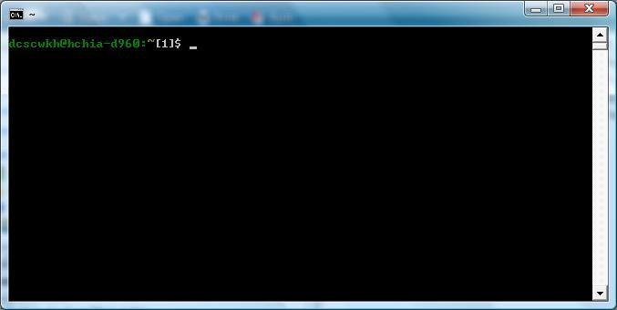
cygwin.command (for Mac)
For a Mac, we do not rely on the UNIX functionality of Cygwin. In fact, the Mac is already based on BSD UNIX. You need to first start up the Terminal application from Finder/Applications/Utilities.
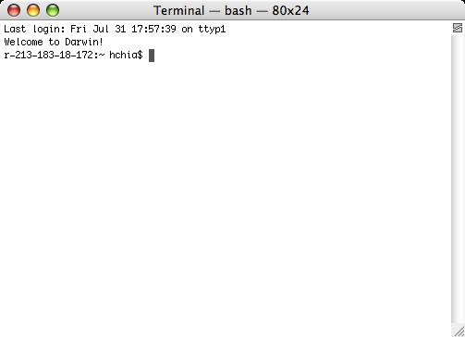

This section may not be applicable to CS1020.
Next, check if the "g++" C++ compiler exists by entering the command "g++ --version". If a "command not found" message is output, then you will need to install Xcode. You can install Xcode either directly from the Installation DVD that comes with your Mac, or you can create an online Apple Developer Connection (ADC) account from http://developer.apple.com/mac/. Once your ADC account is created, you may login, then download and install Xcode. You will see a similar Terminal session as shown below.
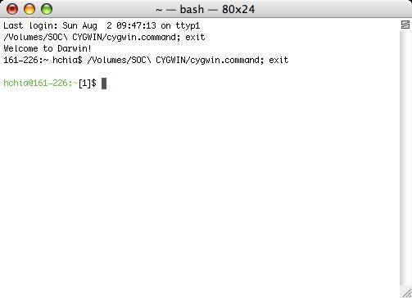
Instead of double clicking "cygwin.command", you can enter the command (with its associated path) directly from within the usual Terminal session. The correct command to enter is shown when you performed the double click earlier. From the preceding example, notice that the command is "/Volumes/SOC\ CYGWIN/cygwin.command".

Whichever method you use, as long as you see the local UNIX prompt of the form "user@machine:~[xxx]$" , then you would have successfully performed the necessary setup on your local machine.
Note that user and machine varies with different users and machines, and xxx is a running number. You are now at the home directory level of your very own UNIX platform. All the common UNIX commands can now be used. To exit, do not close the window by clicking on × at the top corner. Just enter the command "exit". You may also open multiple windows, if necessary, by repeatedly clicking on "cygwin.bat" or "cygwin.command".

Acknowledgement:

We should thanks Dr. Henry Chia for creating this package. He has put in a lot of time and efforts to create this for the benefit of all of us.

